EMERGENCY CONTACT AND MEDICAL RELEASE
AIR MINNESOTA
AAU BASKETBALL
Player: ___________________________________ Date of Birth: _______________
Family Physician: ___________________________ Phone: ____________________
Address: ____________________________________________________________
Hospital Preference: ___________________________________________________
In case of emergency Contact: List 2 Name and number
_____________________________________________________________________
Please list any allergies/medical problems, including that require maintenance medication (i.e. Diabetic,Asthma, and Seizure Disorder)
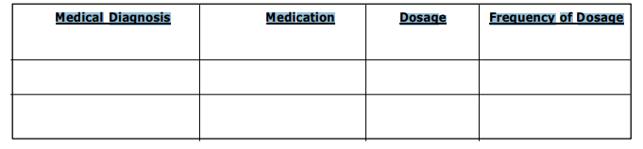The purpose of the above listed information is to ensure that medical personnel have details of any medical problem which may interfere with or alter treatment.
Any other medical considerations that the coaches should be aware of: _________________________________________________________________________
Medical Insurance Carrier: ____________________________
Policy #: _______________
Date of last Tetanus Toxoid Booster: _____________________
Parent or Guardian Authorization:
In case of emergency, if family physician cannot be reached, I hereby authorize my child to be treated by Certified Emergency Personnel (i.e. EMT, First Responder, E.R. Physician):
Mr./Mrs./Ms. _________________________________________________ Date: _________
Authorized Parent/Guardian Signature
Print Parent/Guardian Name _____________________________________________
NOTE: From to be carried by Team Manager/Coach together with team roster or eligibility affidavit during all practices and games

